**Chapter 7: Activity 4**

1. No runtime error message will be displayed when a user enters a number which is bigger than the maximum number of elements the array can store (for example, 6).
2. Usually an error message will only appear when the program is closed.
3. 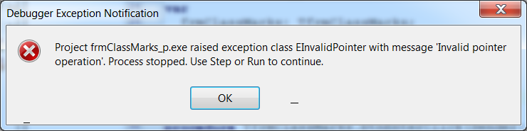An example of the error message (in Delphi 2010) is as follows:

You will have to click on the menu options **Run|** **Program Reset** to stop the program from executing.

1. This happens because data was written to an illegal area in memory when a value was assigned, for example, to arrMarks[6].
2. (See the Delphi program for the code which can be used to prevent out-of-range errors.)

repeat

iNum := StrToInt(InputBox('Class marks','How many marks will you enter?',''));

if iNum > MAXNUMMARKS then

ShowMessage('A maximum of ' + IntTostr(MAXNUMMARKS) + ' may be entered.') ;

until iNum <= MAXNUMMARKS;

Note:

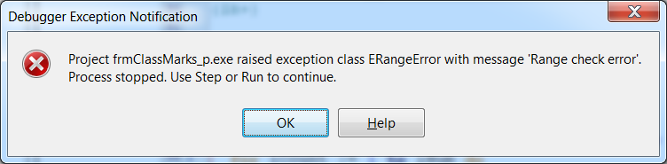When the compiler directive {$R+} is added to the program, the program will display a more user-friendly error message the first time a value is entered which falls out of the range of the array.

The program will still crash, and you will have to stop it by clicking on **Run|** **Program Reset.** But at least you will be warned about this error while you are still developing the program. These type of error messages should never appear once your program has been finalised.